Live Site (Checklist if present in current Live Site)
Please refer to this document for the listed menu items: https://docs.google.com/document/d/16o8QFN8rlmX99Rd1yw9wrI8wRuqSIGQNMmI4jZLXZpA/edit?tab=t.0

Attached links may serve as reference for the content.

PAGES:
- Dental Implants
  - Dental Implants [https://www.jeffreyburns.com/restorative-dentistry/dental-implants/]
    - *single dental implants and how they work
- Might it be this ? [https://www.jeffreyburns.com/restorative-dentistry/dental-implants/overview-of-implant-placement/]
✳️combine the info from the above link with info from sources like this: https://www.perio.org/for-patients/periodontal-treatments-and-procedures/dental-implant-procedures/single-tooth-dental-implants/
    - *implant supported bridges
✳️ take info from here:
https://my.clevelandclinic.org/health/treatments/10921-dental-bridges

    - *how dental implants work
- Might it be this? Same link as single dental implants [https://www.jeffreyburns.com/restorative-dentistry/dental-implants/overview-of-implant-placement/]
✳️ take info from here instead of the single dental implants https://www.fda.gov/medical-devices/dental-devices/dental-implants-what-you-should-know
    - Brief description of Full Mouth Dental Implants and Implant Supported Dentures and Link to these two dental implant pages (which will be more in depth
  - Full Mouth Dental Implants
- Maybe this? [https://www.jeffreyburns.com/restorative-dentistry/dental-implants/missing-all-upper-or-lower-teeth/] ////take some of the info here and put it towards the bottom of the page…as it should be like “how we can help you” - Use the info from the link below or other relevant sources as the main information. [make sure to paraphrase to avoid outright copyrighting, or provide references to your sources]
✳️Combine with info from here: https://www.perio.org/for-patients/periodontal-treatments-and-procedures/dental-implant-procedures/full-mouth-dental-implants/
  - Implant Supported Dentures
- Reference this: https://my.clevelandclinic.org/health/treatments/24303-implant-supported-dentures (implant retained dentures is different from implant supported dentures)
- General Dentistry (Other Services)
General Dentistry (https://www.flossseattle.com/why-floss/what-is-general-dentistry) - the services that fall under general dentistry can be listed here (in the document link provided at the top:
  - General Dentistry
  - Pediatric Dental Care
  - Dental Bridges *talk about traditional bridges vs implant bridges
  - Dental Crowns
  - Wisdom Teeth Removal
  - Tooth Extraction
  - Root Canal
  - Bone Grafting
  - Dentures *full and partial dentures
  - Pediatric Dental Care [https://www.jeffreyburns.com/preventative-care/child-dentistry/]
  - Dental Bridges *talk about traditional bridges vs implant bridges
- [https://www.jeffreyburns.com/restorative-dentistry/dental-bridges/]
Note: no mention of traditional bridges vs implant bridges
- ✳️take some info from here or other relevant sources: https://www.harlemdentistry.com/blog/implant-bridge-vs-traditional-bridge
  - Dental Crowns [https://www.jeffreyburns.com/restorative-dentistry/dental-crowns/]
  - Wisdom Teeth Removal [https://www.jeffreyburns.com/preventative-care/wisdom-teeth-removal/]
  - Tooth Extraction - https://www.jeffreyburns.com/preventative-care/tooth-extractions/
  - Root Canal [https://www.jeffreyburns.com/restorative-dentistry/root-canal/]
  - Bone Grafting
Take some info from here: https://my.clevelandclinic.org/health/treatments/21727-dental-bone-graft and combine with some relevant info from here: https://www.jeffreyburns.com/restorative-dentistry/l-prf-grafting-and-osstell-idx/

  - Dentures *full and partial dentures [https://www.jeffreyburns.com/restorative-dentistry/dentures/]
- Partial Dentures: [https://www.jeffreyburns.com/restorative-dentistry/dentures/partial-dentures/]
- Full Dentures
Reference here: https://my.clevelandclinic.org/health/treatments/10900-dentures
- Cosmetic Dentistry [https://www.jeffreyburns.com/cosmetic-dentistry-4/]
  - Porcelain Veneers [https://www.jeffreyburns.com/cosmetic-dentistry-4/porcelain-veneers/]
  - Teeth Whitening [https://www.jeffreyburns.com/cosmetic-dentistry-4/teeth-whitening/]
  - Clear Braces [https://www.jeffreyburns.com/cosmetic-dentistry-4/clear-braces/]
- Meet Dr. Burns [https://www.jeffreyburns.com/about-us/dr-jeffrey-burns/]
- Resources *These pages will not be a direct response, they are just extra information for the patients. They will be able to be accessed from the menu drop down.
  - New Patient Forms
- Live New Patients page but no forms [https://www.jeffreyburns.com/patient-information/new-patients/]
  - Financing/Insurance [https://www.jeffreyburns.com/patient-information/insurance/cherry-credit/]
  - Patient Education (which is what we will name the “blog”)
- Live Blog page [https://www.jeffreyburns.com/blog/]
- Live Patient Education page (not much content) [https://www.jeffreyburns.com/patient-information/patient-education/]

- Contact [https://www.jeffreyburns.com/contact-us/]
- Note image below for devs (include these):
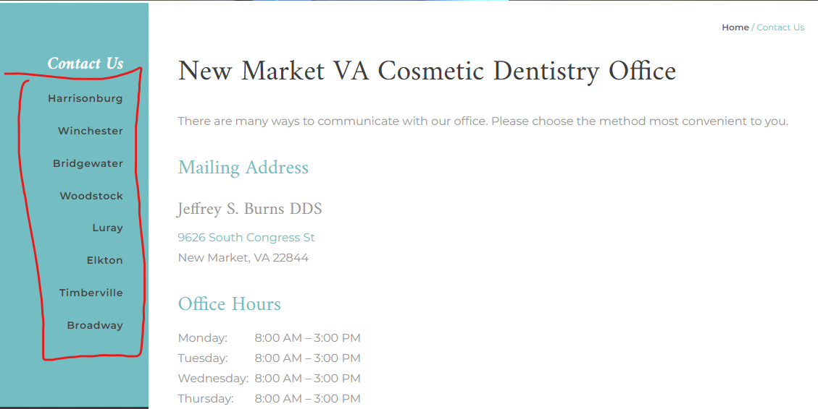

Subpages/Blog pages
- Anesthesia [https://www.jeffreyburns.com/patient-information/anesthesia/]
- Dental Exams and Check-Ups [https://www.jeffreyburns.com/preventative-care/dental-exams-and-check-ups/]
- Oral Hygiene [https://www.jeffreyburns.com/preventative-care/oral-hygiene/]
- Teeth Cleaning [https://www.jeffreyburns.com/preventative-care/teeth-cleaning/]
- Dental Sealants [https://www.jeffreyburns.com/preventative-care/dental-sealants/]
- Gum disease treatment
- No content link: https://www.jeffreyburns.com/preventative-care/gum-disease-treatment/
- Links below have content:
- Deep Teeth Cleaning [https://www.jeffreyburns.com/preventative-care/gum-disease-treatment/deep-teeth-cleaning/]
- Periodontal Maintenance [https://www.jeffreyburns.com/preventative-care/gum-disease-treatment/periodontal-maintenance/]
- Restorative Care
- https://www.jeffreyburns.com/restorative-dentistry/]
- Dental Fillings [https://www.jeffreyburns.com/restorative-dentistry/dental-fillings/]

Summary as of 5/07/2026

Here's a summary of the sites listed in the Updated Page list but are not in the current live site. Please see the checklist docs link for more detailed context.

1. Dental Implants Page
a. Dental Implants
- Single Dental Implants
- Implant Supported Bridges
- How dental implants work
- Brief description of Full Mouth Dental Implants and Implant Supported Dentures
b. Full Mouth Dental Implants
c. Implant Supported Dentures

2. General Dentistry
a. General Dentistry
b. Dental Bridges
c. Tooth Extraction
d. Bone Grafting
e. Dentures
- Full Dentures

3. Resources
a. New Patient Forms

4. Subpages/blog pages
a. Restorative Care

